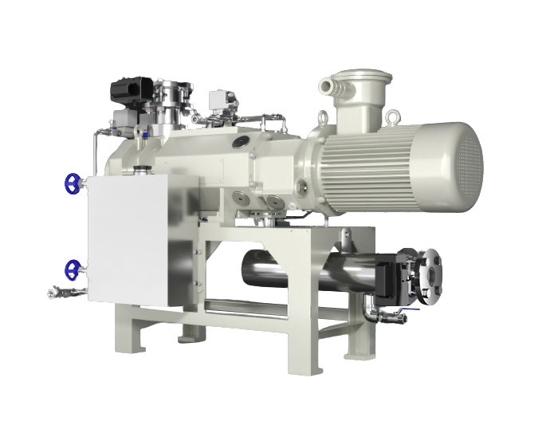
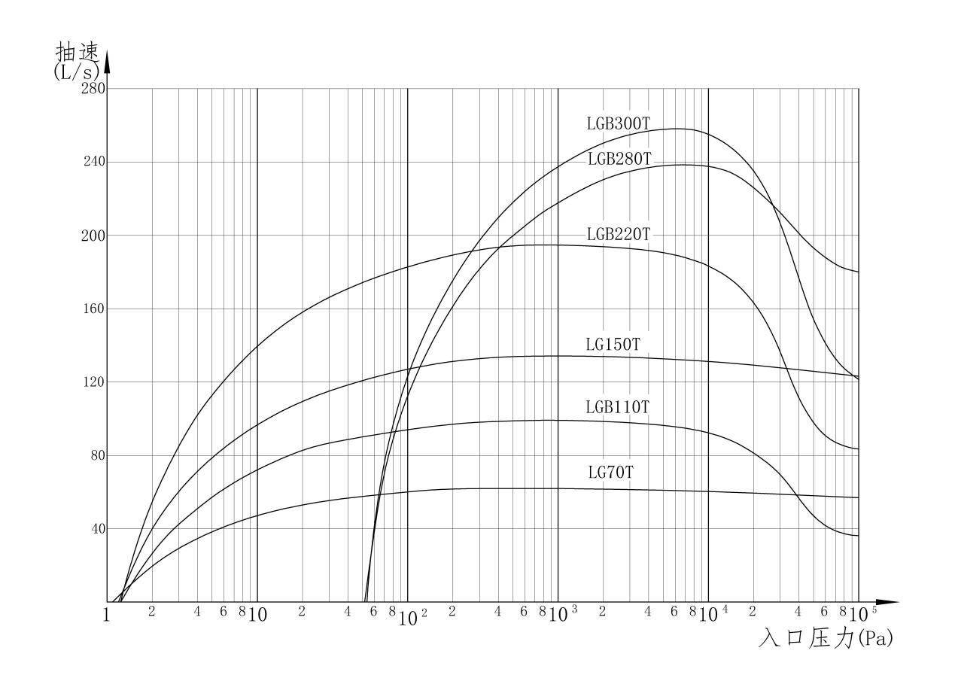

The titanium alloy screw vacuum pump is a special application product for harsh corrosive conditions. The flow surfaces inside the pump are all made of high-quality and high-performance titanium alloy materials, featuring excellent corrosion resistance, high strength, and good stability. The combination of titanium and oxygen is extremely strong, and the surface of the titanium alloy easily forms a dense oxide film, providing the part surface with strong anti-corrosion capabilities. Practical cases have shown that the titanium alloy pump is suitable for extracting most corrosive media such as hydrogen chloride, thionyl chloride, nitric acid, organic acids, bases, and inorganic salts.

